Name

Mathematics Stage 5 Core
Measurement Error

Book 1 |  | Version: 261002  Feedback:  https://MrDingMaths.com
Contents
Syllabus Content 2
Learning Intention 3

Syllabus Content
MA5-MAG-C-01 solves measurement problems by using scientific notation to represent numbers and rounding to a given number of significant figures
Find absolute and percentage error
- Determine the precision of a measuring instrument by finding the smallest division on the instrument
- Find the absolute error of measuring instruments ($absolute error=\frac{1}{2}×precision$)
- Calculate the percentage error of a given measurement by applying the formula: $percentage error=\frac{absolute error}{measurement}×100\%$

Absolute Error

- Inaccuracy
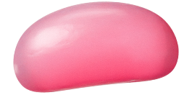
- The ruler to the right is measuring the length of a jellybean.
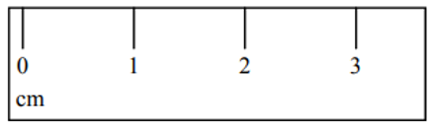
- Since the ruler measures to the nearest centimetre,
it is impossible to say precisely what the length is.

- All measuring instruments have some inaccuracy, depending on how precise it is.

- Precision
- The precision of a measuring instrument is the smallest unit it can measure.
- Unless otherwise stated, it is the smallest place value of the stated measurement.

- Identify precision of a measuring instrument
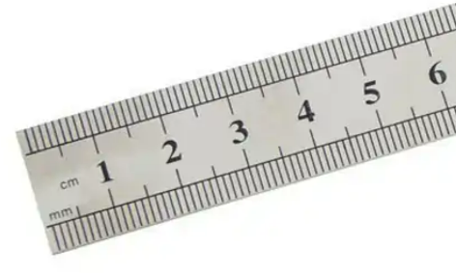 | 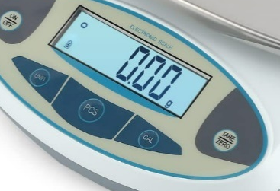 | 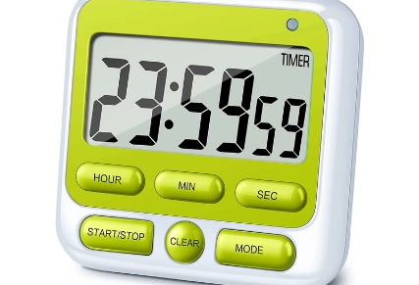
- 18 cm | - 2.4 kg | - $13.15 L$
- 263 ms | - 134.7 g | - 130 m (nearest 10)
- 1460 g (nearest 10) | - 25.50 mm | - 3.0 mg

- Limits of Accuracy
- The limits of accuracy describe the possible values that a measurement could be, considering the inaccuracies of the measuring instrument.

On a ruler with 1 cm increments,
a measurement of 2 cm could be anything from 1.5 to 2.5 cm

$$Absolute Error=\frac{1}{2}×Precision \\ Lower Bound=Measurement-Absolute Error \\ Upper Bound=Measurement+Absolute Error$$
- To find the limits of accuracy:
- Identify the precision.
- Identify the absolute error.
- Find the upper bound.
- Find the lower bound.

- Example Calculate the upper and lower bound of a measurement
State the limits of accuracy for a measurement of 16 s  1. Precision 1 s  2. Absolute error 0.5 s  3. Upper limit 16 + 0.5 = 16.5 s  4. Lower limit 16 – 0.5 = 15 | State the limits of accuracy for a measurement of 9.38 m  1. Precision 0.01 m  2. Absolute error 0.005 m  3. Upper limit 9.38 + 0.005 = 9.385 m  4. Lower limit 9.38 – 0.005 = 9.375 m

- Guided Practice
Determine the limits of accuracy for these measurements.
- 72 cm  Precision: 1 cm  Absolute Error: …………  Lower limit: ………………………  Upper limit: ………………………  71.5 – 72.5 cm | - 86.6 mm  Precision: …………  Absolute Error: …………  Lower limit: ………………………  Upper limit: ………………………  86.55 – 86.65 mm
- 0.57 cm  Precision: …………  Absolute Error: …………  Lower limit: ………………………  Upper limit: ………………………  0.565 – 0.575 cm | - 90 m (nearest 10 metres)  Precision: …………  Absolute Error: …………  Lower limit: ………………………  Upper limit: ………………………  85 – 95 m
- A rectangular garden was measured as 3 m by 5 m, to the nearest metre.
Find the lower limit of the area of the garden.

11.25 m²

- Key Ideas
- The precision of a measuring instrument is the …………………… unit it can measure,
- The absolute error is …………… of the precision.
- The lower bound of a measurement is found by ………………… the absolute error from the measurement.
- The upper bound of a measurement is found by adding the ………………… …………… to the measurement.

Foundation
- Complete the following, referring to the diagram below.

  - When using the measurement scale, we are measuring to the nearest …………
1
  - The absolute error is 0.5 $×$ ……… = ………
0.5 $×$ 1 = 0.5
  - If a measurement is quoted as 16, it could be anything from ……… up to ………
15.5 to 16.5
- Complete the following, referring to the diagram below.
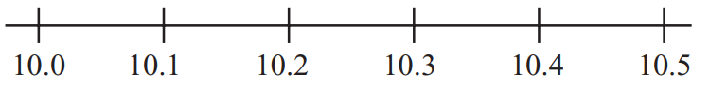
  - When using the measurement scale, we are measuring to the nearest …………
0.1
  - The absolute error is 0.5 $×$ ……… = ………
0.5 $×$ 0.1 = 0.05
  - If a measurement is quoted as 10.4, it could be anything from …….. up to ………
10.35 to 10.45
- Complete the following for a measurement of 9.45 m
  - This measurement of length has been made to the nearest …………,
so the smallest unit on the measuring instrument is …………
Precision = …………
0.01 m, 0.01 m, 0.01 m
  - The absolute error = $0.5$ $×$ …… = ………
0.005
  - Limits of accuracy = 9.45 ± ……… = ………… and …………
9.45 $±$ 0.0-5 = 9.445 and 9.455
  - ………… $≤$ true length $≤$…………
9.445 and 9.455
- Match the scale with the absolute error.
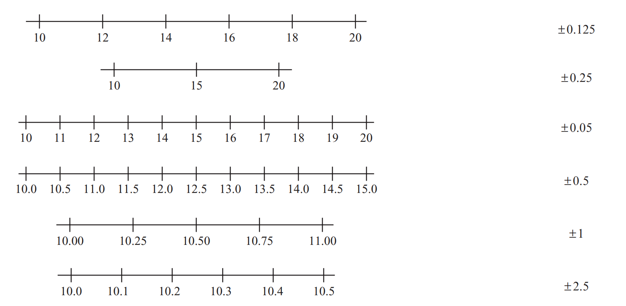

a – E, b – F, c – D, d – A, e – C
- Determine the precision and absolute error for these two rulers.
Precision: ……………  1  Absolute error: ……………  0.5 | 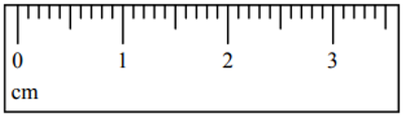  Precision: ……………  0.1  Absolute error: ……………  0.05

- The length, $x$, of a field is given as 90 m.
Write the error interval for $x$ if this measurement is correct to
- the nearest metre  P: 1 m  AE: 0.5 m  $$89.5≤x≤90.5$$ | - the nearest 10 metres  P: 10 m  AE: 5 m  $$85≤x≤95$$

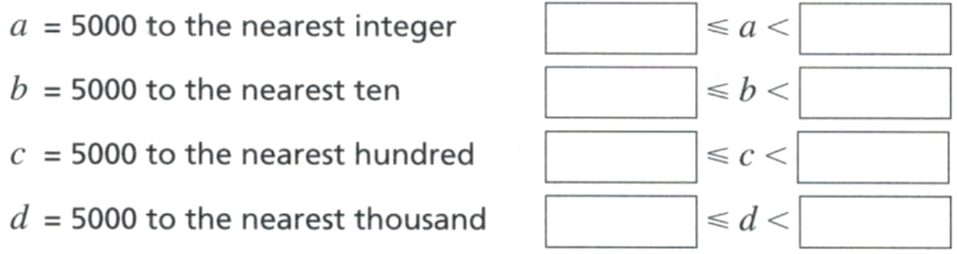
- Complete the error interval for each statement.
4999.5 to 5000.5
4995 to 5005
4950 to 5050
4500 to 5500

- Write the limits of accuracy for each of these numbers.
- $p=60$ to the nearest 10  $$55≤p≤65$$ | - $q=24.7$ to 1 decimal place  $$24.65≤q≤24.75$$
- $x=85$, to the nearest integer  $$84.5≤x≤85.5$$ | - $x=85.0$, correct to 1 decimal place.  $$84.95≤x≤85.05$$

- The time taken for a plane flight is 6 $\frac{1}{2}$ hours, to the nearest $\frac{1}{2}$ hour.
Find the lower and upper bounds of the true measurement.

P: 0.5 hours
AE: 0.25 hours
$6.75 to 6.25$ hours

Development
- 2019 HSC Standard 2 Band 5
A person's weight is measured as 79.3 kg. What is the absolute error of this measurement?

P: 0.1 kg
AE: 0.05 kg
- The size of an angle $a$ is given by the error interval $87.5≤a<88.5°$
  - Write three possible values of $a$ correct to 1 decimal place.

87.8, 87.9, 88.3°
  - What is the size of angle $a$ correct to the nearest integer?
88°

- Determine the upper and lower limits of these measurements.
- A section of road to be repaired is measured as 870 m in length, to the nearest 10 m.  865 to 875 m | - A horse is measured to weigh 485 kg, to the nearest 5 kg.  482.5 to 487.5 kg
- A solution is measured to have 4.72 g of copper sulphate, to the nearest 0.01 g.  4.715 to 4.725 g | - A chocolate bar is measured as 91.0 g, to the nearest 0.5 g.  90.75 to 91.25 g

- Cody measures the mass of an object to be 6 kg.
Jacinta says the same object is 5.8 kg and Lachlan gives his answer as 5.85 kg.
  - Explain how all three people could have different answers for the same measurement, assuming they all measured correctly.

They used measurement tools with different precision.
  - Write down the possible precision of the measuring instrument being used by each person.

Cody: 1 kg, Jacinta: 0.1 kg, Lachlan: 0.01 kg
- A square’s side length was measured to be 15 cm, to the nearest cm.
  - What is the lower limit of the length?
15 cm
15 cm
14.5 cm
  - Therefore, what is the lower limit of the area?
14.5 $×$ 14.5 = 210.25 cm²
  - What is the upper limit of the length?
15.5 cm
  - Therefore, what is the upper limit of the area?
15.5 $×$ 15.5 = 240.25 cm²
  - Therefore, what are the limits of accuracy for the area?
210.25 to 240.25 cm²

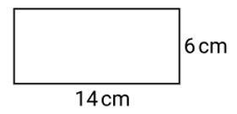
- Determine the upper limit for the area of this rectangle.

14.5 $×$ 6.5 = 94.25 cm²
- A rectangular room is 5.4 m long and 3.2 m wide.
What is the lower limit for the area of the room?

5.35 $×$ 3.15 = 16.8525 m²
- A pizza tray was measured to be 28.6 m in diameter.
What is the lower and upper limit for the area of the pizza tray?

$$Lower =π{\left(\frac{28.55 }{2}\right)}^{2}=640.18 m^{2}$$
$$upper=π{\left(\frac{28.65}{2}\right)}^{2}=644.72 m^{2}$$

Percentage Error

- Percentage Error
- The percentage error compares the absolute error to the measurement.

$$Percentage Error=\frac{Absolute Error}{Measurement}×100$$

- Identify the precision. This is the smallest place value of the measurement.
- Identify the absolute error; the absolute error is half the precision.
- Calculate the percentage error using the formula.

- Example Calculate the upper and lower bound of a measurement
18 kg  1. Precision 1 kg  2. Absolute error 0.5 kg  3. Percentage error $\frac{0.5}{18}$ $×100=2.778\%$ | 18.4 kg  1. Precision 0.1 kg  2. Absolute error 0.05 kg  3. Percentage error $\frac{0.05}{18.4}$ $×100=0.272\%$

- Guided Practice
Calculate the percentage error of these measurements. Give your answer to 3 d.p.
- 49.6 kg  Precision: …………  Absolute Error: …………  Percentage Error: ………………  0.101% | - 251 g  Precision: …………  Absolute Error: …………  Percentage Error: ………………  0.199%
- 50 mL (nearest 10 mL)  Precision: …………  Absolute Error: …………  Percentage Error: ………………  10% | - 5.256 L  Precision: …………  Absolute Error: …………  Percentage Error: ………………  0.010%

- Key Ideas
- The percentage error is the absolute error divided by the ……………………, then multiplied by 100.

Foundation
- Vivian measured the mass of an iPhone as 251 g.
  - Identify the precision.
1 g
  - Calculate the absolute error.
0.5 g
  - Find the limits of accuracy.

250.5 to 251.5 g
  - Find the percentage error. Answer correct to two decimal places.
$$\frac{0.5}{251}×100=0.20\%$$

- Abbey measured the mass of a dishwasher as 49.6 kg.
  - Find the limits of accuracy.
P: 0.1 kg
AE: 0.05 kg
49.55 to 49.65 kg
  - Find the percentage error correct to two decimal places.

$$\frac{0.05}{49.6}×100=0.10\%$$

- Sally measured the mass of an LCD screen as 2.71 kg.
  - Find the limits of accuracy.

P: 0.01 kg
AE: 0.005 kg
2.705 to 2.715 kg
  - Find the percentage error correct to three decimal places.

$$\frac{0.005}{2.71}×100=0.185\%$$

- Find the percentage error for an object measured as 13.0 cm, to the nearest 0.5 cm.
Answer to 2 d.p.
P: 0.5
AE: 0.25
$$\frac{0.25}{13}×100=1.92\%$$

Development
- 2015 HSC Standard 2 Band 5
The length of a fish was measured to be 49 cm, correct to the nearest cm.
What is the percentage error in this measurement, correct to two decimal places?

Precision: 1 cm
AE: 0.5 cm
$$\% error=\frac{0.5}{49}×100=1.02\%$$
- 2014 HSC Standard 2 Band 5
The top of the Sydney Harbour Bridge is measured to be 138.4 m above sea level.
What is the percentage error in this measurement?

P = 0.1 m
AE = 0.05 m
$$\% error=\frac{0.05}{138.4}×100=0.036\%$$

- 2008 HSC Standard 2 Band 4
The capacity of a bottle is measured as 1.25 litres correct to the nearest 10 millilitres.
What is the percentage error for this measurement?

Precision: 10 mL
AE: 5 mL
$$\% error=\frac{5 mL}{1250 mL}×100=0.4\%$$
- 2017 HSC Standard 2 Band 5
The length of a netball court is measured to be 30.50 metres, correct to the nearest centimetre. What is the lower limit for the length of the netball court?

Precision: 1 cm
AE: 0.5 cm
Lower limit = 30.5 m – 0.5 cm = 30.495 m

